**Host application on ubuntu ect2-instance:**

1. First create user “sudo adduser <username>”
2. Give sudo access to user “sudo usermod -aG sudo <username>”
3. Login as new user “su -u <username>”
4. First update the system “sudo apt-get update”
5. Install postgresql “sudo apt-get install postgresql postgresql-contrib”
6. Show the list of user “sudo /etc/passwd”
7. Login as postgres to create user in postgresqldb:
   1. “sudo -i -u postgres”
   2. “psql -U postgres”
   3. “\password postgres”
8. Change directory cd /etc/postgresql/12/main/
9. Open the fil “sudo vi postgresql.conf”
10. Change listen_addresses to ‘*’
11. Open the file “sudo vi pg_hba.conf”
12. Edit the file:
13. 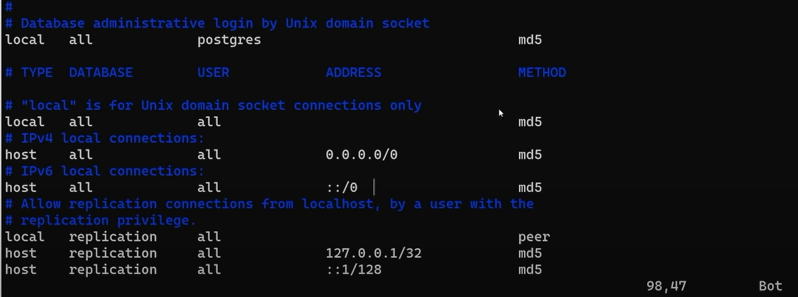
14. Change directory : cd /usr/lib/systemd/system
15. Restart postgres “systemctl restart postgresql.service”
16. Crete directory “mkdir <directory name>” and go inside it
17. Create virtual environment “virtualenv <name>”
18. Activate virtual env “source <name>/bin/activate”
19. To deactivate type deactivate.
20. Create another folder “mkdir <src>” go inside
21. Clone project from github “git clone <url> .”
22. Install python packages using requirement.txt “pip install -r requirement.txt”
23. Got to home directory “cd ~”
24. Create env file “touch .env”
25. Edit .env file “vi .env” give all your environment variable.
26. To set “set -o allexport; source <.env file path>; set +o allexport”
27. Listout environment variable “printenv”
28. When we reboot machine all our environment variable will be lose to mitigate we need to add “set -o allexport; source <.env file path>; set +o allexport” at bottom of .profile file. (.profile file present in home directory)
29. Start app “gunicorn -w 4 -k uvicorn.workers.UvicornWorker app.main:app --bind 0.0.0.0:8000”
30. Creating service:
    1. Got to “cd /etc/systemd/system”
    2. Sudo vi <server name>.service
    3. Copy the below content
       1. [Unit]
       2. Description=demo fastapi application
       3. After=network.target
       4. [Service]
       5. User=vishwa
       6. Group=vishwa
       7. WorkingDirectory=/home/vishwa/app/src/
       8. Environment="PATH=/home/vishwa/app/venv/bin"
       9. EnvironmentFile=/home/vishwa/.env
       10. ExecStart=/home/vishwa/app/venv/bin/gunicorn -w 4 -k uvicorn.workers.UvicornWorker app.main:app --bind 0.0.0.0:8000
       11. [Install]
       12. WantedBy=multi-user.target
31. Run the service “systemctl start fastapi.service”
32. Install nginx “sudo apt install nginx -y”
33. Go to folder “cd /etc/nginx/sites-available”
34. Edit default file:
    1. “sudo vi default”
       1. proxy_pass http://localhost:8000;
       2. proxy_http_version 1.1;
       3. proxy_set_header X-Real-IP $remote_addr;
       4. proxy_set_header X-Forwarded-For $proxy_add_x_forwarded_for;
       5. proxy_set_header Upgrade $http_upgrade;
       6. proxy_set_header Connection 'upgrade';
       7. proxy_set_header Host $http_host;
       8. proxy_set_header X-NginX-Proxy true;
       9. proxy_redirect off;